Many-to-Many

🌟 Definition
# Source: AI Source: Provided by: [Data Path: Persons Table -> ID Column: 1, Name_En Column: Motasem Essam] -> From: [ChatGPT] on [6/10/2026]
A Many-to-Many (M:N) Relationship exists when many records in Entity A can be related to many records in Entity B.
In other words:
Many A ↔ Many B
Each side can have multiple related records on the other side.

🎯 Purpose
# Source: AI Source: Provided by: [Data Path: Persons Table -> ID Column: 1, Name_En Column: Motasem Essam] -> From: [ChatGPT] on [6/10/2026]
Many-to-Many relationships are used when:
- Both entities can have multiple associations.
- Neither side is limited to a single relationship.
- Real-world connections are naturally many-to-many.

🧠 Simple Example
# Source: AI Source: Provided by: [Data Path: Persons Table -> ID Column: 1, Name_En Column: Motasem Essam] -> From: [ChatGPT] on [6/10/2026]
Students and Courses
One Student → Many Courses
One Course → Many Students
Therefore:
Students ↔ Courses
is a Many-to-Many relationship.

Diagram
Students M ───── N Courses

📚 Real-World Examples

1. Students ↔ Courses
# Source: AI Source: Provided by: [Data Path: Persons Table -> ID Column: 1, Name_En Column: Motasem Essam] -> From: [ChatGPT] on [6/10/2026]
Students M ───── N Courses
A student can take many courses.
A course can have many students.

2. Orders ↔ Products
# Source: AI Source: Provided by: [Data Path: Persons Table -> ID Column: 1, Name_En Column: Motasem Essam] -> From: [ChatGPT] on [6/10/2026]
Orders M ───── N Products
An order can contain many products.
A product can appear in many orders.

3. Authors ↔ Books
# Source: AI Source: Provided by: [Data Path: Persons Table -> ID Column: 1, Name_En Column: Motasem Essam] -> From: [ChatGPT] on [6/10/2026]
Authors M ───── N Books
A book can have multiple authors.
An author can write multiple books.

4. Employees ↔ Projects
# Source: AI Source: Provided by: [Data Path: Persons Table -> ID Column: 1, Name_En Column: Motasem Essam] -> From: [ChatGPT] on [6/10/2026]
Employees M ───── N Projects
An employee can work on many projects.
A project can have many employees.

📊 ER Diagram Representation
# Source: AI Source: Provided by: [Data Path: Persons Table -> ID Column: 1, Name_En Column: Motasem Essam] -> From: [ChatGPT] on [6/10/2026]
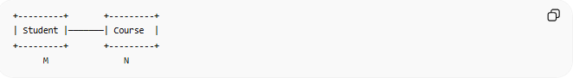
+---------+ +---------+
| Student |───────| Course |
+---------+ +---------+
M N

⚠️ Implementation in Relational Databases
# Source: AI Source: Provided by: [Data Path: Persons Table -> ID Column: 1, Name_En Column: Motasem Essam] -> From: [ChatGPT] on [6/10/2026]
A Many-to-Many relationship cannot be implemented directly.
Instead, it requires a Junction Table (also called a Bridge Table or Associative Table).

Example: Students and Courses
Students Table
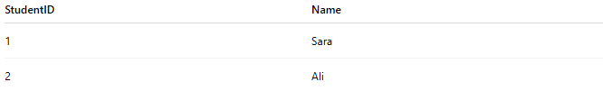
StudentID | Name
1 | Sara
2 | Ali

Courses Table
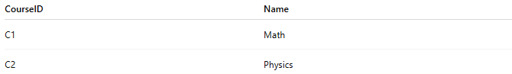
CourseID | Name
C1 | Math
C2 | Physics

Enrollment Table (Junction Table)
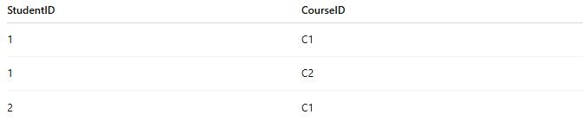
StudentID | CourseID
1 | C1
1 | C2
2 | C1
This table connects students and courses.

🔗 How the Junction Table Works
# Source: AI Source: Provided by: [Data Path: Persons Table -> ID Column: 1, Name_En Column: Motasem Essam] -> From: [ChatGPT] on [6/10/2026]
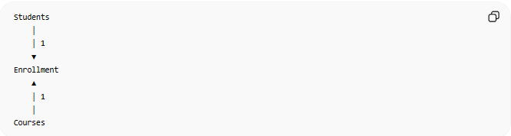
Students
│
│ 1
▼
Enrollment
▲
│ 1
│
Courses
The Enrollment table converts:
Many-to-Many
into:
One-to-Many + One-to-Many

🗄️ SQL Example
# Source: AI Source: Provided by: [Data Path: Persons Table -> ID Column: 1, Name_En Column: Motasem Essam] -> From: [ChatGPT] on [6/10/2026]
Students
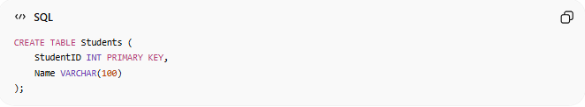
CREATE TABLE Students (
StudentID INT PRIMARY KEY,
Name VARCHAR(100)
);

Courses
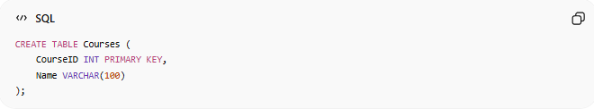
CREATE TABLE Courses (
CourseID INT PRIMARY KEY,
Name VARCHAR(100)
);

Enrollment
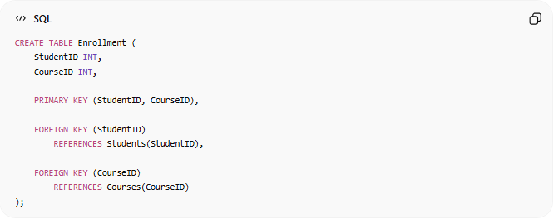
CREATE TABLE Enrollment (
StudentID INT,
CourseID INT,
PRIMARY KEY (StudentID, CourseID),
FOREIGN KEY (StudentID)
REFERENCES Students(StudentID),
FOREIGN KEY (CourseID)
REFERENCES Courses(CourseID)
);

🔢 Characteristics of a Many-to-Many Relationship
# Source: AI Source: Provided by: [Data Path: Persons Table -> ID Column: 1, Name_En Column: Motasem Essam] -> From: [ChatGPT] on [6/10/2026]
- Multiple records on both sides.
- Requires a junction table.
- Very common in complex systems.
- Implemented using two foreign keys.

🌍 Online Store Example
Relationship
Orders ↔ Products

Orders
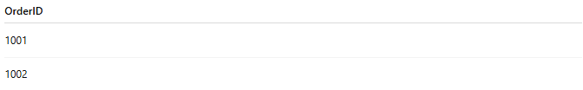
OrderID
1001
1002

Products
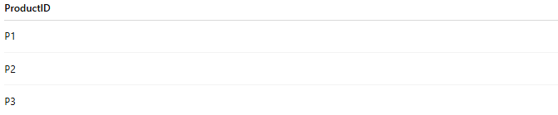
ProductID
P1
P2
P3

OrderProducts (Junction Table)
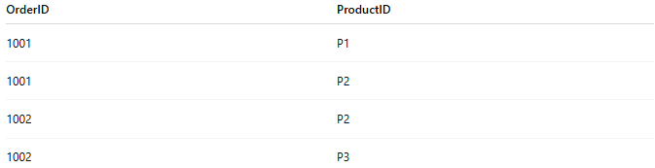
OrderID | ProductID
1001 | P1
1001 | P2
1002 | P2
1002 | P3
One order contains many products.
One product appears in many orders.

⚠️ Many-to-Many vs One-to-Many
# Source: AI Source: Provided by: [Data Path: Persons Table -> ID Column: 1, Name_En Column: Motasem Essam] -> From: [ChatGPT] on [6/10/2026]
One-to-Many
Customer 1 ───── N Orders
Each order belongs to one customer.

Many-to-Many
Students M ───── N Courses
Both sides can have many relationships.

Comparison
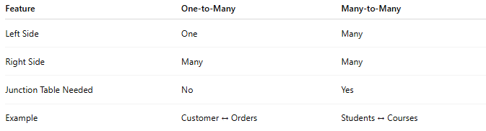
Feature | One-to-Many | Many-to-Many
Left Side | One | Many
Right Side | Many | Many
Junction Table Needed | No | Yes
Example | Customer ↔ Orders | Students ↔ Courses

📚 Common Many-to-Many Examples
# Source: AI Source: Provided by: [Data Path: Persons Table -> ID Column: 1, Name_En Column: Motasem Essam] -> From: [ChatGPT] on [6/10/2026]
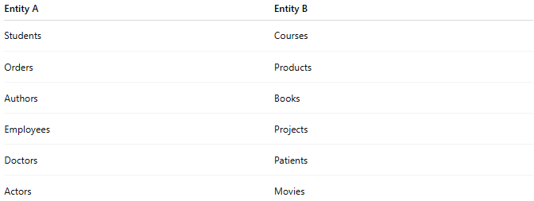
Entity A | Entity B
Students | Courses
Orders | Products
Authors | Books
Employees | Projects
Doctors | Patients
Actors | Movies

🧠 Simple Analogy
# Source: AI Source: Provided by: [Data Path: Persons Table -> ID Column: 1, Name_En Column: Motasem Essam] -> From: [ChatGPT] on [6/10/2026]
Think of students and clubs:
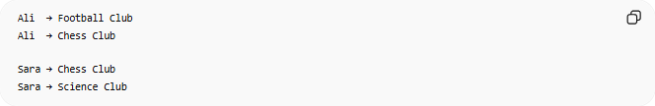
Ali → Football Club
Ali → Chess Club
Sara → Chess Club
Sara → Science Club
- One student can join many clubs.
- One club can have many students.
This is a Many-to-Many Relationship.

🧭 Summary
# Source: AI Source: Provided by: [Data Path: Persons Table -> ID Column: 1, Name_En Column: Motasem Essam] -> From: [ChatGPT] on [6/10/2026]
A Many-to-Many (M:N) Relationship occurs when multiple records in one entity can be associated with multiple records in another entity. Examples include Students–Courses, Orders–Products, and Employees–Projects. In relational databases, Many-to-Many relationships are implemented using a junction table containing foreign keys from both entities.

